  \ |  |   GOLD’S GYM AMIRYAN  GROUP EXERCISE TIMETABLE 16.03.2015 –26.04.2015
GGX STUDIO | TIME | MONDAY | TUESDAY | WEDNESDAY | THURSDAY | FRIDAY | SATURDAY | SUNDAY
GGX STUDIO | 09:30 |  | LATINO DANCE |  | 
GGX STUDIO | 10:30 |  |  |  |  | 
GGX STUDIO | 11:00 |  |  |  |  |  | 
GGX STUDIO | 12:00 |  |  |  |  |  |  | 
GGX STUDIO | 13:00 |  |   PUMP |  | PUMP |  |  | 
GGX STUDIO | 14:00 |  |  |  |  |  | 
GGX STUDIO | 15:00 |  |  | 
GGX STUDIO | 16:00 |  |  |  |  |  | 
GGX STUDIO | 17:00 |  |  |  | 
GGX STUDIO | 18:00
GGX STUDIO | 18:30 |  |  | LATINO DANCE
GGX STUDIO | 19:30 |  | 
GGX STUDIO | 20:30 |  |  |  |  | 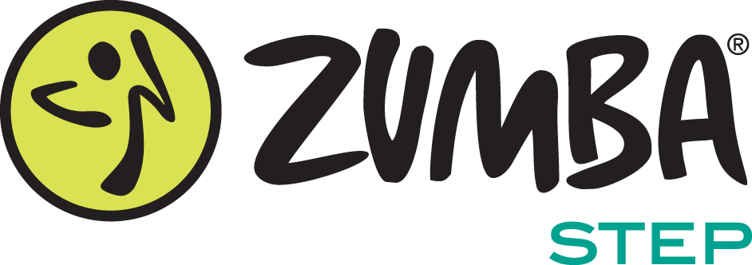
MIND&BODY STUDIO | 11:30 | 
MIND&BODY STUDIO | 15:00 |  | PRENATAL YOGA |  | PRENATAL YOGA
MIND&BODY STUDIO | 16:00 |  |  |  |  |  |  | 
MIND&BODY STUDIO | 18:30
MIND&BODY STUDIO | 19:30
MIND&BODY STUDIO | 20:30
POOL | 11:45 |  | 
POOL | 15:15

